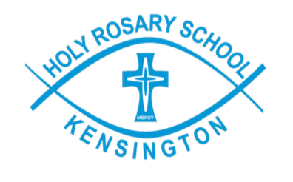

STUDENT DETAILS:

First Name |  | Surname |  | DOB

SCHOOL TRANSFER DETAILS:

Current School
E No. | E | School |  | Suburb
New School / Catholic Education Commission of Victoria Ltd (CECV)
E No. | E1088 | School | Holy Rosary School | Suburb | Kensington

The teacher/principal has discussed with me/us how and why certain information about my child is provided to the new school. I understand that in addition to formal reports etc. details regarding the educational program will be supplied.

I/We provide informed and express consent for all relevant health and/or educational information held by school A, detailed below, to be provided to Holy Rosary School, Kensington. I understand that this information will be collected and used by Holy Rosary School, Kensington to inform health and safety management strategies and educational programming for my child.

TYPE OF INFORMATION:
(e.g. personalised learning plans/student program, medical reports, specialist notes, information regarding adjustments, medical management plans, attendant care plans, behaviour support plans, safety plans)
Date | Author (e.g. psychologist’s, medical practitioner’s name) | Title (e.g. speech pathologist, psychologist, paediatrician) | Description (e.g. cognitive assessment, language assessment)

CONSENT:

Parent/Carer/Guardian Name: | Parent/Carer/Guardian Signature:  Date:
Parent/Carer/ Guardian Name: | Parent/Carer/Guardian Signature:  Date:

Please refer to each school’s information about their use and disclosure of information, and information regarding their privacy policy. Further clarification is available on request from the principals.

