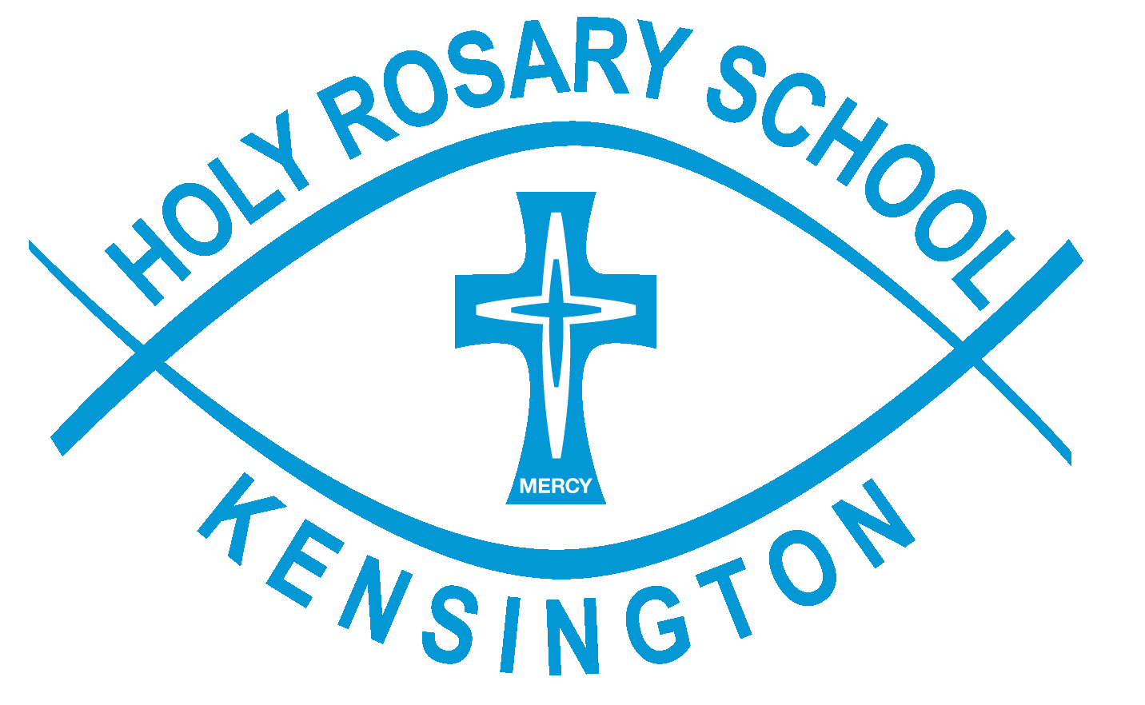
Dear Parents

I write to you to confirm that Holy Rosary School will follow the recommendation from the Victorian Government and the Chief Health Officer that school holidays commence from tomorrow, Tuesday 24 March. As a result, today was the final day of classes for Term 1, 2020.

Students were asked to take school and library books, and stationery home at the conclusion of classes today in the event of a possible transition to flexible remote learning. For students who were absent today, parents are welcome to collect these items tomorrow or Wednesday during office hours.

For those parents who work in essential services (ambulance, fire, police, hospitals, medical professions) the school can provide supervision for your children during school hours, if required, for the remainder of this week. If you wish to do this, please notify me tonight; principal@hrkensington.catholic.edu.au.

As of Tuesday 24 March, the OSHC program will only cater for children whose parents are working in essential services. The program will run before and after school as per normal operating hours, until the end of the week, and normal charges will apply.

We expect that Term 2 will begin for students on Wednesday 15 April. Any changes to these dates will be guided by the ongoing advice of the Chief Health Officer, and will be communicated to parents. It is at this time that you will be advised of flexible remote learning, should that be required. Access to online learning and documents will be provided at this time.

The Department of Health and Human Services has a number of resources on its website, which explain the virus, detail risk-reduction practices and behaviours, and answer frequently asked questions. These are available at www.dhhs.vic.gov.au/coronavirus.

You can also find information about Catholic Education’s response to COVID-19 at www.cecv.catholic.edu.au/Coronavirus-information-for-parents.

In the meantime, we thank you for your ongoing understanding as we seek to keep our school community safe. Further updates will be provided as I become aware of them.

I wish you a safe holiday and pray that you and your loved ones remain well.

Kind regards,

Chris

